Murray, Kenneth Crosthwaite (b. 1902, Wolverhampton, England – d. 1972, Lagos, Nigeria)

Kenneth Crosthwaite Murray was a British colonial officer in Nigeria and the founding director of the department of antiquities in colonial Nigeria. He arrived in Nigeria in 1927 to work for the education department. Murray was an itinerate art teacher, travelling across southern Nigeria, developing the art curriculum, and training teachers. He influenced artists such as Uthman M. Ibrahim and Ben C. Enwonwu, who were considered part of the Murray School. His ideas on modern African art were disseminated across the country, influencing artist-teachers such as Akinola Lasekan. Throughout his career, Murray undertook many efforts to preserve and promote Nigerian artistic heritage including curating and lending to national and international exhibitions, requesting the repatriation of protected works, documenting and collecting antiquities and regulating their export. Further contributing to modernism and art preservation in Nigeria, Murray established the department of antiquities and facilitated the opening of seven museums before independence in 1960: The House of Images at Esie (1945), The Jos Museum (1952), the Ife Museum (1954), Nigerian Museum in Lagos (1957), Oron Museum (1958), Benin Museum (1960), the Historic House Museum in Kano (1960).

In the summer of 1936 Murray, along with his colleague, Arthur Hunt-Cooke, was sent to Ibadan and Abeokuta to study Yoruba crafts. During this survey Murray became aware of the loss of traditional arts in Nigeria. He began actively collecting work throughout southern Nigeria. Murray began his quest to establish museums early in his career and called for help from organizations in Britain and Nigeria to support the arts and preserve antiquities. During World War II, Murray sent his collection of over 200 objects to South Africa while he served in the West African Forces. He was discharged from duty in July 1943 when he returned to Nigeria to begin a formal survey of antiquities of Nigeria.

This survey led to the founding of the department of antiquities in 1946. The department wrote antiquities legislation, established the protocol for archaeological excavations, and developed a museum program. To build the department, Murray worked closely with Bernard E. B. Fagg, a colonial officer stationed in Jos, Nigeria, who was appointed government archaeologist in 1948. During Murray’s tenure as director, seven museums were opened in Nigeria: The House of Images at Esie (1945), The Jos Museum (1952), the Ife Museum (1954), Nigerian Museum in Lagos (1957), Oron Museum (1958), Benin Museum (1960), the Historic House Museum in Kano (1960).

Murray also helped pass the 1953 Antiquities Ordinance, which regulated the export of Nigerian cultural artifacts and sought the repatriation of Nigerian antiquities that left the country during the Benin Punitive Expedition of 1897, Leo Frobenius’ expedition from 1910-1912, and William Bascom’s research trip in 1938.

Murray served as director of the department from its inception in 1946 until his retirement in 1957, with the opening of the museum in Lagos. He remained in the country and became an advocate for local fishermen’s rights and continued to help catalogue and write about the collection he built for the Nigerian Museum, Lagos. In 1964 he came out of retirement and was nominated once again as the director of the department of antiquities until 1967. He died in a car accident on his way to the Benin Museum on April 22, 1972.

References and further reading:

Fagg, B. (1963) “The Museums of Nigeria,” *Museum* 16 (3): 124-148.

James, V. (1994) “Kenneth Murray, father of Museum Movement in Nigeria,” *Nigerian Heritage* 3: 69-74.

Willett, F., ed. (1973) “Kenneth Murray: Through the Eyes of his Friends,” *African Arts* 6 (4): 2,5,7,74,78,90-93, 75.

List of Works:

Murray, K. (1940) “A Museum for Nigeria,” *Nigeria* (20): 271-274.

Murray, K. (1942) “Art in Nigeria: The Need for a Museum,” *Journal of the Royal African Society* 41 (165): 241-249.

Murray, K. (1943) “Arts and Crafts of Nigeria: Their Past and Future,” *Africa: Journal of the International African Institute* 14 (4): 155-164.

Murray, K. (1947) “Ekpu: The Ancestor Figures of Oron, Southern Nigeria,” *The Burlington Magazine for Connoisseurs* 89 (536): 310 and 312-315.

Murray, K. (1952) “The Colonial Art Exhibition,” *The Nigerian Field* 17 (1): 41-42.

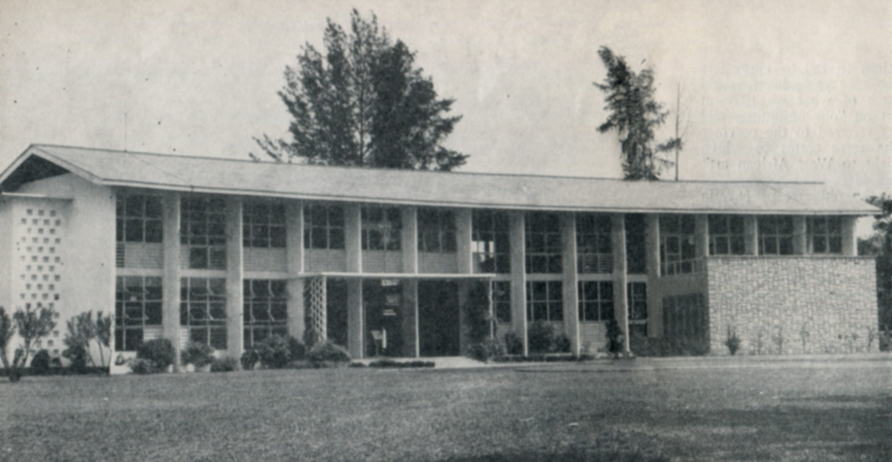

The National Museum, Lagos (1957), exterior view. Photo: Bernard E. B. Fagg (1959), *Preserving the Past*, Lagos: Nigerian Federal Ministry of Research and Information, p. 6-7.